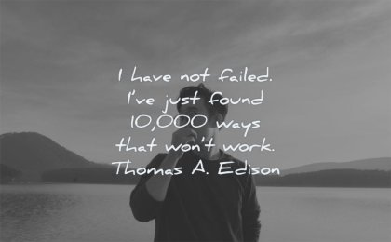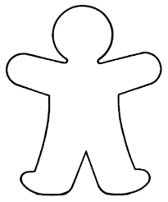

What do I need to do to achieve this? ________________________________________________________________________________________________________________________________________________________________________________________________________

Who might I need to get some help from? ___________________________________________________________________________________________________________________

What is your why?

What I want in life: _________________ ________________________________________________________________________________________________________________________________________________________________ What I don’t want in life: ___________________ ______________________________________________________________________________________________

|  |  |  |  |
| --- | --- | --- | --- |
| Statement | Always | Sometimes | Never |
| I write important school/work dates down / set a reminder in my phone |  |  |  |
| I plan ahead – I know how far ahead of a test I need to start revising |  |  |  |
| If I have a test, I know when it is going to be |  |  |  |
| I spend **enough** time revising for a test / mock |  |  |  |
| I leave most of my revision to the night before the test |  |  |  |
| I don’t revise for tests |  |  |  |
| I get nervous about tests, but I can handle it |  |  |  |
| If I’ve done enough revision or it’s a subject I feel I know quite well, I feel less stressed about a test |  |  |  |
| Tests don’t really worry me |  |  |  |
| I know why I get the results I get in a test |  |  |  |
| My test results are disappointing |  |  |  |
| If I work hard and feel prepared, my test results are OK |  |  |  |

Personalise your little you



Pick one more bad habit … how could you ‘solve’ it?

____________________________________________________________________________________________________

Pick one bad habit … how could you ‘solve’ it?

_____________________________________________________________________________________

My worst work habits are …

________________________________________________________________________________________________________________________________________________________________________________________________